OOP LAB
24 - FEB – 2025

Devika.B
ROLL NO : 22
24MP2265

Experiment 8

Employee Search Using an Array of
Objects

AIM :

Write a Java program to store employee details including employee number, name, and
salary, and search for an employee by employee number.

SOURCECODE

import java.util.Scanner;
class Employee {
int empNumber;
String empName;
double salary;
Employee(int empNumber, String empName, double salary) {
this.empNumber = empNumber;
this.empName = empName;
this.salary = salary;
}
void display() {
System.out.println("Employee Number: " + empNumber);
System.out.println("Employee Name: " + empName);
System.out.println("Salary: $" + salary);
}
}
public class EmployeeSearch {
public static void main(String[] args) {
Scanner scanner = new Scanner(System.in);
System.out.print("Enter the number of employees: ");
int n = scanner.nextInt();
Employee[] employees = new Employee[n];
for (int i = 0; i < n; i++) {
System.out.println("Enter details for Employee " + (i + 1) + ":");
System.out.print("Employee Number: ");
int empNumber = scanner.nextInt();
scanner.nextLine(); // Consume newline
System.out.print("Employee Name: ");
String empName = scanner.nextLine();
System.out.print("Salary: ");
double salary = scanner.nextDouble();
employees[i] = new Employee(empNumber, empName, salary);
}
System.out.print("\nEnter employee number to search: ");
int searchNumber = scanner.nextInt();
boolean found = false;
for (Employee emp : employees) {
if (emp.empNumber == searchNumber) {
System.out.println("\nEmployee Found:");
emp.display();
found = true;
break;
}
}
if (!found) {
System.out.println("Employee not found!");
}
scanner.close();
}
}

OUTPUT
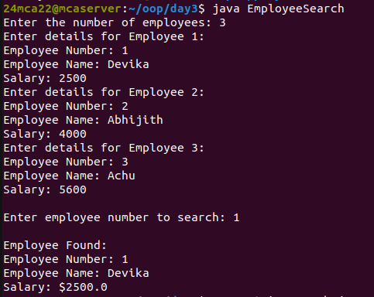

Experiment 9

String Search in an Array

AIM :
Write a Java program to store ‘n‘ strings in an array. Search for a given string. If found,
print its index; otherwise, display ”String not found.”

SOURCECODE

import java.util.Scanner;
public class StringSearch {
public static void main(String[] args) {
Scanner scanner = new Scanner(System.in);
System.out.print("Enter the number of strings: ");
int n = scanner.nextInt();
scanner.nextLine();
String[] strings = new String[n];
System.out.println("Enter the strings:");
for (int i = 0; i < n; i++) {
strings[i] = scanner.nextLine();
}
System.out.print("Enter the string to search: ");
String searchString = scanner.nextLine();
int index = -1;
for (int i = 0; i < n; i++) {
if (strings[i].equals(searchString)) {
index = i;
break;
}
}
if (index != -1) {
System.out.println("String found at index: " + index);
} else {
System.out.println("String not found.");
}
scanner.close();
}
}

OUTPUT

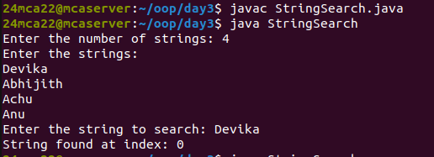

Experiment 10

String Manipulations

AIM :
Write a Java program to perform various string manipulations, including finding the
length, converting to uppercase and lowercase, extracting characters and substrings, and
reversing the string.

SOURCECODE

import java.util.Scanner;
public class StringManipulations {
public static void main(String[] args) {
Scanner scanner = new Scanner(System.in);
System.out.print("Enter a string: ");
String str = scanner.nextLine();
System.out.println("Length of the string: " + str.length());
System.out.println("Uppercase: " + str.toUpperCase());
System.out.println("Lowercase: " + str.toLowerCase());
System.out.print("Enter index to extract character: ");
int index = scanner.nextInt();
if (index >= 0 && index < str.length()) {
System.out.println("Character at index " + index + ": " + str.charAt(index));
} else {
System.out.println("Invalid index!");
}
System.out.print("Enter start and end index for substring: ");
int start = scanner.nextInt();
int end = scanner.nextInt();
if (start >= 0 && end <= str.length() && start < end) {
System.out.println("Substring: " + str.substring(start, end));
} else {
System.out.println("Invalid substring range!");
}
String reversed = new StringBuilder(str).reverse().toString();
System.out.println("Reversed string: " + reversed);
scanner.close();
}
}

OUTPUT

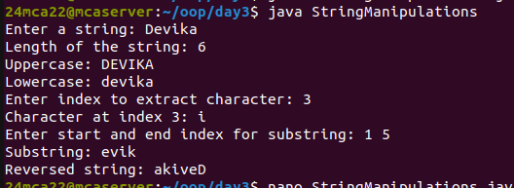

Experiment 11

Inheritance in Java

AIM :

Write a Java program to implement hierarchical inheritance for a book management
system. Define a base class ‘Publisher‘, a derived class ‘Book‘, and two subclasses ‘Liter-
ature‘ and ‘Fiction‘. Include methods to read and display book details and demonstrate
the functionality using user input.

SOURCECODE

import java.util.Scanner;
class Publisher {
String publisherName;

Publisher(String publisherName) {
this.publisherName = publisherName;
}
void displayPublisher() {
System.out.println("Publisher: " + publisherName);
}
}
class Book extends Publisher {
String bookTitle;
String author;
Book(String publisherName, String bookTitle, String author) {
super(publisherName);
this.bookTitle = bookTitle;
this.author = author;
}
void displayBook() {
displayPublisher();
System.out.println("Book Title: " + bookTitle);
System.out.println("Author: " + author);
}
}
class Literature extends Book {
String genre = "Literature";
Literature(String publisherName, String bookTitle, String author) {
super(publisherName, bookTitle, author);
}
void displayDetails() {
displayBook();
System.out.println("Genre: " + genre);
}
}
class Fiction extends Book {
String genre = "Fiction";
Fiction(String publisherName, String bookTitle, String author) {
super(publisherName, bookTitle, author);
}
void displayDetails() {
displayBook();
System.out.println("Genre: " + genre);
}
}
public class BookManagement {
public static void main(String[] args) {
Scanner scanner = new Scanner(System.in);
System.out.println("Enter Literature Book Details:");
System.out.print("Publisher: ");
String pub1 = scanner.nextLine();
System.out.print("Book Title: ");
String title1 = scanner.nextLine();
System.out.print("Author: ");
String author1 = scanner.nextLine();
Literature literatureBook = new Literature(pub1, title1, author1);
System.out.println("\nEnter Fiction Book Details:");
System.out.print("Publisher: ");
String pub2 = scanner.nextLine();
System.out.print("Book Title: ");
String title2 = scanner.nextLine();
System.out.print("Author: ");
String author2 = scanner.nextLine();
Fiction fictionBook = new Fiction(pub2, title2, author2);
System.out.println("\n--- Literature Book Details ---");
literatureBook.displayDetails();
System.out.println("\n--- Fiction Book Details ---");
fictionBook.displayDetails();
scanner.close();
}
}

OUTPUT

